***Assignment # 2***

|  |  |
| --- | --- |
| **Name** | Muhammad Asad |
| **Roll #** | 2019-EE-383 |
| **Section** | A-G1 |



***Programming Fundamentals***

**Lab # 2**

* **Objectives:**
* The first objective of this lab is to develop the concept of variables.
* The second objective of this lab is to build the understanding related to declaration of a variable.
* The third objective of this lab is to learn initialization of a variable that is previously declared with any of the data type.
* The fourth objective of this lab is to learn the conversion techniques of data types.
* **Task # 1:**

Declare a variable of integer data type and initialize it and print the variable. Try redeclaring and reinitializing the variable separately. Comment whether re-declaration or re-initialization was successful or not. Contain single and multiple line comments.

* **Code:**

public class NewClass {

public static void main (String[] args){

**/*Here we are declaring that**

**x is an integer*/**

int x;

**//Here we are initializing x with 5**

x=5;

System.out.println(x);

**/*Now we are Re-declaring**

**the variable x*/**

int x;

**//Here this Redeclared Variable will be reinitialized with 7 and print it**

x=7;

System.out.println(x);

}

}

* **Output:**

For simple Declaration and Initialization, the output is:

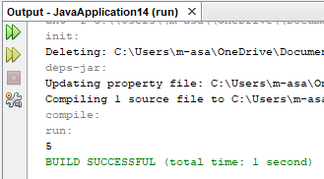

* In the above code, the output was an error because occurred redeclared the same variable;
* **Error:**





* **Reason:**

This error is because that we cannot declare the same variable again as we have already declared the variable x above with data type int. The only way to declare is with other variable instead of x.

**Q:**

* **What are Data types and what are their advantages?**
* **Answer:**

Data type specifies the size and type of values that can be stored in an identifier Data types in Java are classified into two types:

**Primitive**—which include:

Integer, Character, Boolean, and Floating Point.

**Non-primitive**—which include:

Classes, Interfaces, and Arrays.

* **Advantages:**
* Creating the data types are the efficient way of using memory in a computer, because if a variable takes small memory why we provide it extra space. This helps in computer efficiency.
* Integer and float and many other data types are different and cannot be compiled. So compiler gives syntax error, sometimes illogical outputs will be printed.
* **Conversion Techniques:**

In Java, conversions can occur in three ways:

* Assignment conversion
* Promotion
* Casting

We will be using casting technique for conversion of data type.

* **Casting Possibilities:**
* int / int = int
* float / float =float
* int / float =float / int = float

This table may help in understanding the size of a data type and its range:

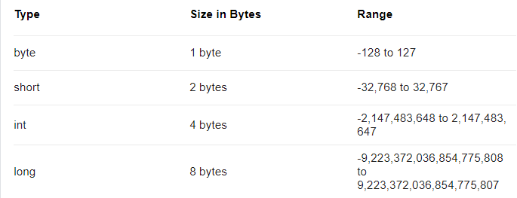

* **Task # 2:**

Change the data type of a variable implicitly and explicitly. You should demonstrate both casting types separately and comment both casting types separately.

**Using implicit casting**

* **Code:**

public class JavaApplication16 {

public static void main(String[] args) {

int x;

**//We declared x as integer type**

x=21;

**/*And initialized with a value*/**

float y;

**//We declared a new variable y as float**

y=x;

**/*Here implicit casting occurred**

**where we initialized y with x(an integer)*/**

System.out.println(y);

}

}

* **Output:**

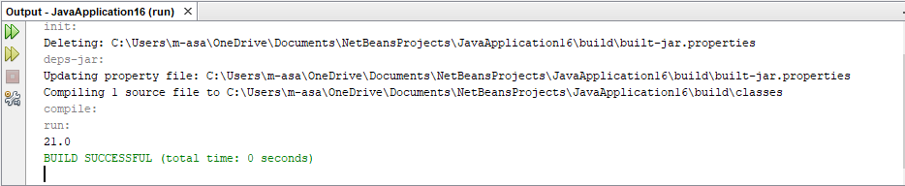

**Using Explicit Casting**

* **Code:**

public class JavaApplication16 {

public static void main(String[] args) {

float x;

**//We declared the variable x as float**

x=(int)(6/4);

**/*We explicity told the computer**

**to get the answer in integer and store in x**

**where x is initialized with (6/4)*/**

System.out.println(x);

}

}

* **Output:**

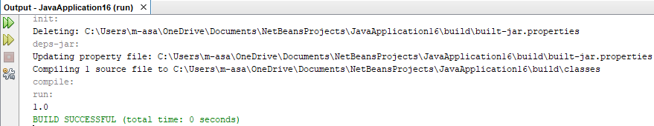

* **Conclusion:**
* This lab helped me upgrading my mental abilities about programming.

There is a difference between java and python language. I think that the java is more useful programming language. This lab helped me to understand the concepts of variable.

* In python we simply used to declare a variable simply and can be redeclared later on.
* But in java, we declare it by assigning any of the data type and cannot be redeclared again.
* This lab helped me to understand the concept of initialization.
* There is no difference in method of initializing a variable in java and python. But there is a slight difference in the syntax of both languages.
* This lab helped me understanding the methods and techniques to convert the data types.

In python, there is only the way of conversion called casting.

In Java, conversions can occur in three ways:

* Assignment conversion
* Promotion
* Casting